Smart Library Request Workflow in ServiceNow

Final Report

INTRODUCTION

Project Overview
The Smart Library Request Workflow in ServiceNow is designed to automate the process of requesting, approving, and managing library books. It eliminates manual handling by digitizing the workflow, improving efficiency and accuracy.

Purpose
The purpose of this project is to simplify the book borrowing process, reduce delays, and provide real-time tracking of requests through automation.

IDEATION PHASE

Problem Statement
Traditional library systems rely on manual processes for book requests and approvals, leading to delays, errors, and lack of transparency.

Empathy Map Canvas
    - Users need quick access to books
    - Users expect timely approval
    - Users feel frustrated with delays
    - Users want easy tracking

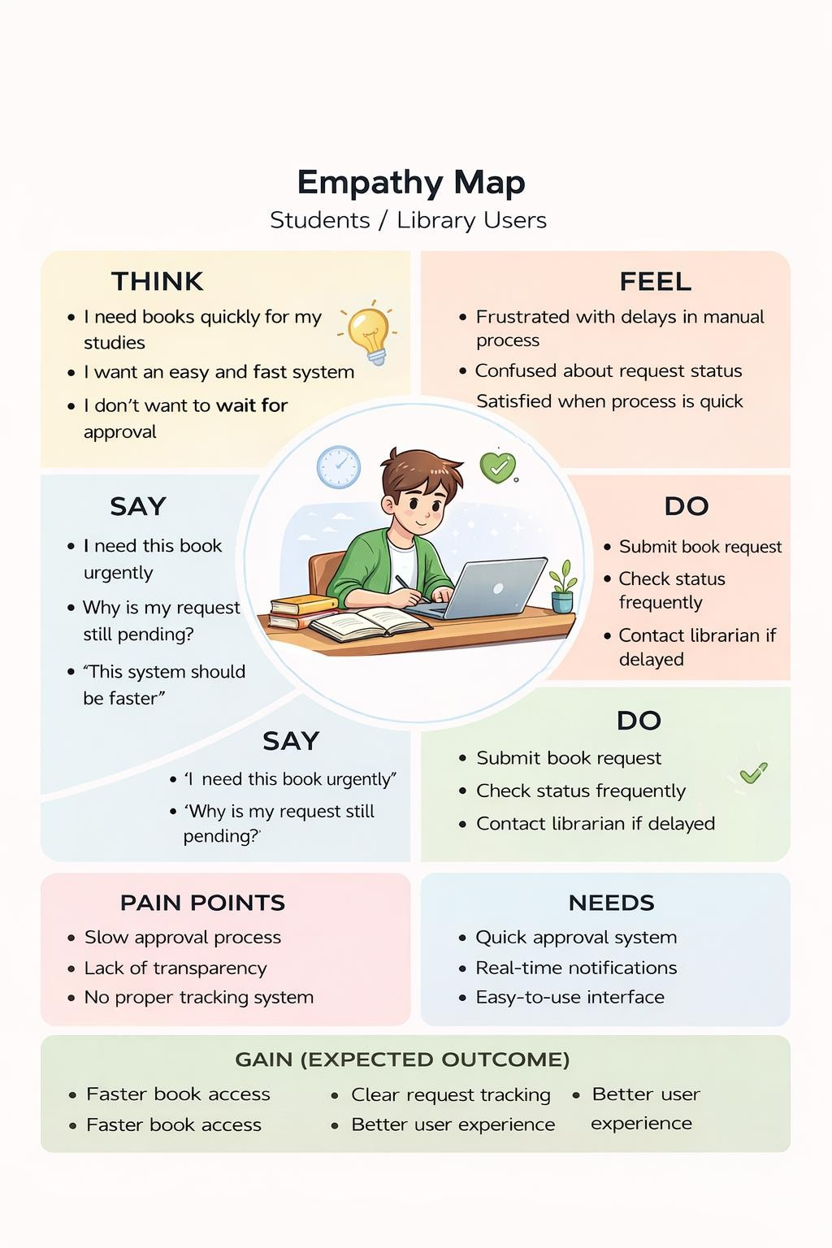

Brainstorming
    - Automate request system
    - Add approval workflow
    - Enable notifications
    - Provide reports for analysis

- REQUIREMENT ANALYSIS
  - Customer Journey Map

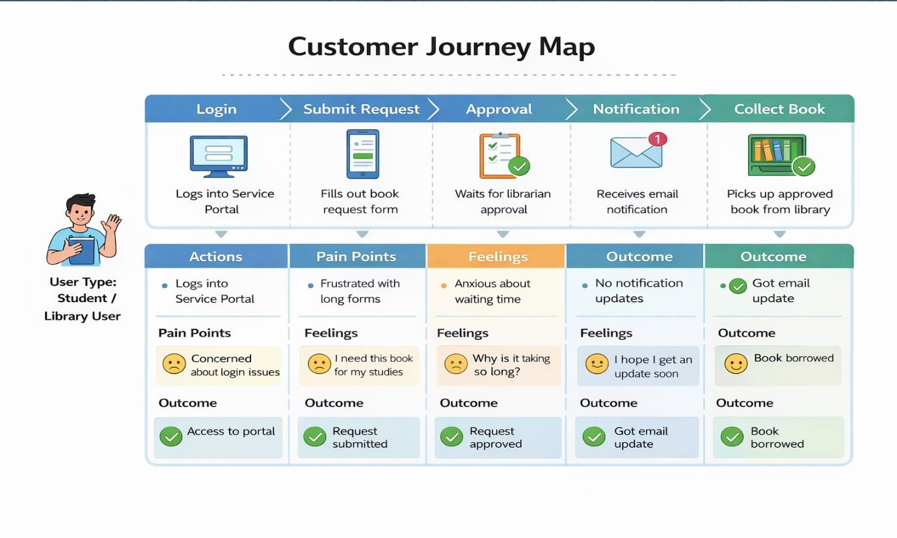

Solution Requirement
    - Request form
    - Approval system
    - Notification system
    - Reporting module

Data Flow Diagram
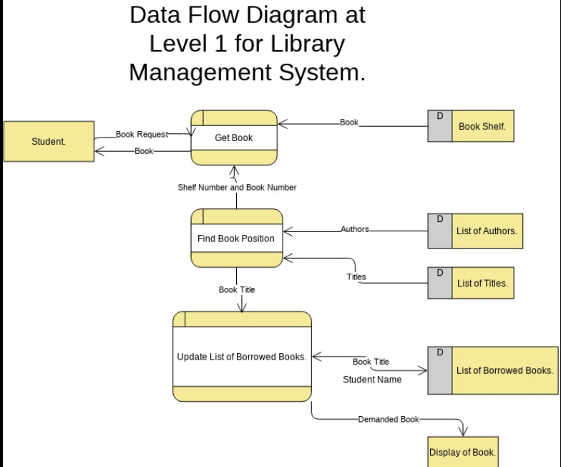
  - Technology Stack
    - ServiceNow Platform
    - Flow Designer
    - UI Policy
    - Access Control (ACL)
    - Reports

Problem Solution Fit
The system matches user needs by providing a fast, automated, and transparent request process.

Proposed Solution
A workflow-based system that automates request submission, approval, and notification.

Solution Architecture

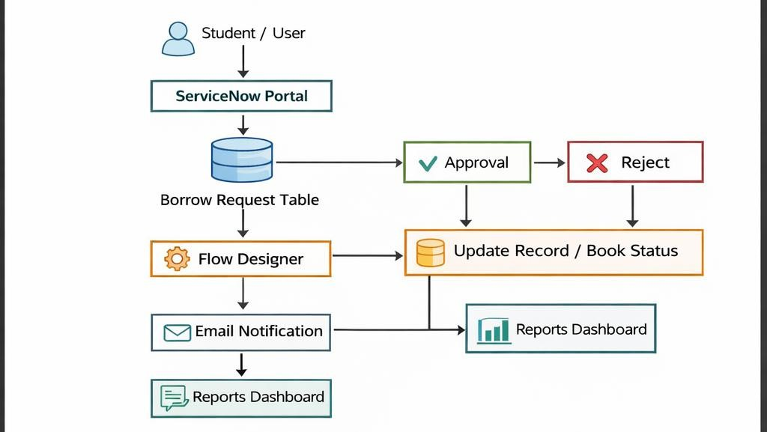

PROJECT PLANNING s SCHEDULING
  - Project Planning
    - Requirement gathering
    - Design phase
    - Implementation
    - Testing
    - Documentation

PROJECT PLANNING s SCHEDULING
  - Project Planning
    - Requirement gathering
    - Design phase
    - Implementation
    - Testing
    - Documentation

FUNCTIONAL AND PERFORMANCE TESTING

Performance Testing
The system was tested for:
    - Fast request processing
    - Accurate approvals
    - Reliable notifications

RESULTS

Output Screenshots
    - Request form
    - Approval flow
    - Email notification
    - Report dashboard

ADVANTAGES s DISADVANTAGES
Advantages
- Automation reduces manual work
- Faster processing
- Improved accuracy
- Real-time updates

Disadvantages
- Requires initial setup
- Depends on system availability

G. CONCLUSION
The Smart Library Request Workflow successfully automates the book request process, improving efficiency, transparency, and user satisfaction.

FUTURE SCOPE
  - Mobile integration
  - Barcode scanning
  - AI-based recommendations
  - Advanced analytics

APPENDIX

Source Code

  - ServiceNow configuration and scripts

Dataset Link

  - Not applicable (system-based data)

GitHub s Project Demo Link

  - https://github.com/pavithradevisenthilkumar/Smart-Library-Request-Workflow- in-ServiceNow.git

